**PROJECT REPORT**

**MINOR PROJECT-I**

**PROGRAM NAME:**

**ONLINE SOCIAL**

**AND**

**MOOD ASSESSMENT**

**NAME OF THE INSTITUTION:**

**AMPLIFY MINDWARE BHARATI VIDHYAPEETH**

**ACKNOWLEDGEMENT**

THIS PROJECT COULD NOT HAVE BEEN SUCCESSFULLY COMPLETED WITHOUT THE UNENDING AND CONTINIOUS SUPPORT AND HELP FROM ALL MY TEACHERS, ESPECIALLY PRASHANT SIR , SNEHAL MAM and CHANDA MAM. ,

I WOULD ALSO LIKE TO THANK MY PARENTS FOR THEIR LOVE AND ENCOURAGEMENT THROUGHOUT THE MAKING OF THIS PROJECT.

SHUBHAM R JAIN

BSCIT/15/008

**DECLARATION**

I hereby declare that this project work titled **“Online Social”** And **“Affect Assessment”** is my original work and no part of it has been submitted for any other degree purpose or published in any other from till date.

**Index Content**

|  |  |  |  |
| --- | --- | --- | --- |
| **Chapter No** | **Content** | | **Page**  **No.** |
| 1 | Project1 Profile | | 5 |
| 2 | System Analysis | | 6 |
| 3 | Hardware & Software Specifications | | 8 |
| 4 | System Design | |  |
|  | 4.1 | Context Diagram | 9 |
|  | 4.2 | Data Flow Diagram | 10 |
|  | 4.3 | Entity Relationship Diagram | 12 |
|  | 4.4 | Data Dictionary | 13 |
| 5 | Input and Output Design | | 25 |
| 6 | Testing | | 29 |
| 7 | Future scope and limitations | | 30 |
| 8 | Project1 Profile | | 33 |
| 9 | System Analysis | | 34 |
| 10 | Hardware & Software Specifications | | 35 |
| 11 | Additional Libraries | | 36 |
| 12 | Input and Output Design | | 37 |
| 13 | Testing | | 41 |
| 14 | Future scope and limitations | | 41 |
| 15 | Conclusion | | 42 |
| 16 | Bibliography | | 42 |

**Project1 Profile**

|  |  |
| --- | --- |
| **Project Title** | WebDevloment for Social  Network. |
| **Project definition** | Social networking-Community site provides communication to various employees of the company and also employees can get also the features as current community Site. |
| **Developer** | Shubham Jaiin |
| **Internal project guide** | Mrs. Snehal Chhajed |
| **Minimum Hardware configuration** | Processor : Intel Pentium-IV Processor  Ram :1 GB  Hard disk : - 20GB |
| **Front end** | Microsoft ASP.Net 2015 with C# |
| **Back end** | SQL Server 2014 |
| **Operating system** | Windows 10 |

**Existing System Study**

* Employees while communicating through phone and internet chat.

* Legal Documents sharing was done with Emails and Manual file works.

When Employee needs communicating with another Employee they have two options:

1. **Phone :-**

In phone communicating it connect with telephone to desire Employee.

1. **Chat :-**

When they are use to internet chat that time it must be read internet.

In sharing of legal document via email employee must be upload a file in email and receiver download a file from email. So, in existing system file sharing task performed by email.

**Project Definition**

Social networking-community site provides communication to various employees of the company and also employees can get also the features as current community site.

* **Registration :-**

When Employees want to add in this application it easily to registration in this application.

* **Manage profile :-**

Employees easily edit profile to desire change.

* **Search Employees :-**

Employees easily search other employees by employee information.

* **Request for employees :-**

Employees can find another employees then send a request for join and add inn own account.

* **Scrap :-**

Send and receiver scrap by employees.

* **Photo Gallery :-**

Employees can easily upload photos own employees account easily.

* **Chat :-**

It is easily communicating with online employees.

* **Feedback :-**

If employees want communicating with employees its feel feedback and send that feedback it direct connect with admin and read that connect.

**Hardware and Software**

Hardware :-( Recommended)

Processor : Intel Pentium-IV Process

Random Access Memory : (Minimum) 512 MB

Hard Disk : 20 GB

Software :-( Recommended)

Front-End : Visual Studio 2008

Web Server : IIS 5.1

Back End : SQL server 2005

Support : Framework 2.0

Operating System : Windows XP (service pack 2)

Supporting tools : Microsoft Word for document

**System Design**

* **Context Diagram For Remote**

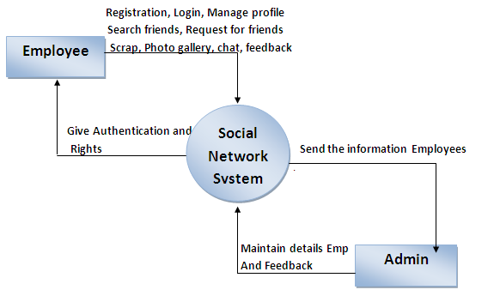

**First Level Diagram**

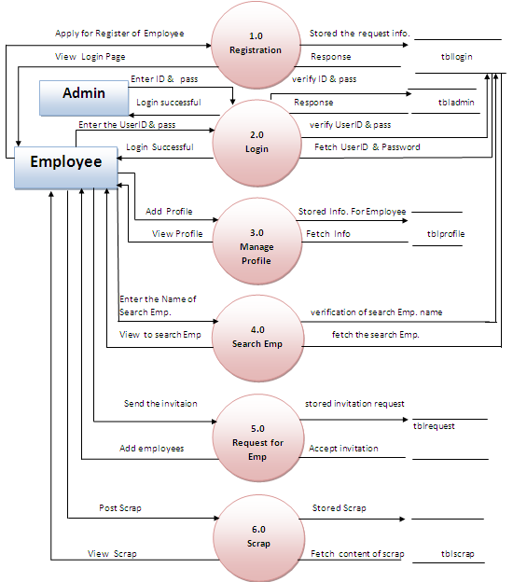

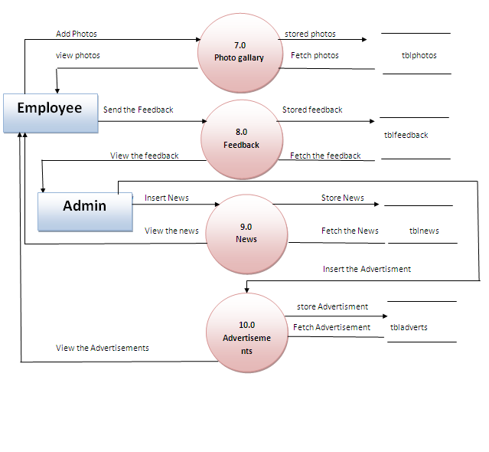

**E-R Diagram**

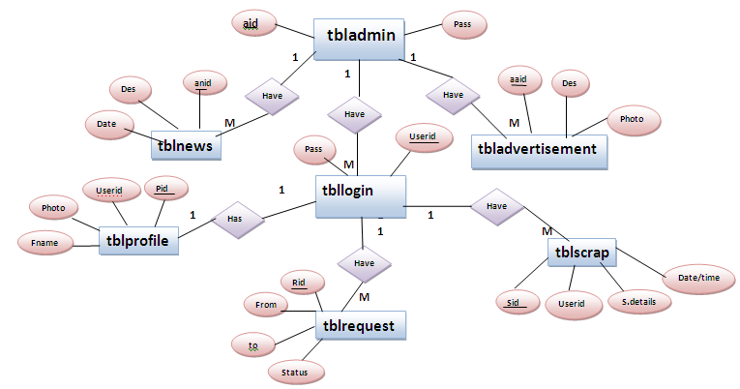

**Data Dictionary**

|  |  |
| --- | --- |
| **Table Known** | **Table Name** |
| Tbllogin | Registration(Login) |
| tblprofile1 | Profile |
| Tblrequest | Request friends |
| Tblscrap | Scrap |
| Tblphoto | Photo gallery |
| Tblfeedback | Feedback |
| Tbladmin | Admin Login |
| Tbladd | Advertisement |
| Tblnews | News |

**Data Dictionary**

Table Name:-tbllogin

Purpose:-Employee login

|  |  |  |  |  |
| --- | --- | --- | --- | --- |
| **Fieldname** | **Data Type** | **Length** | **Constraints** | **Description** |
| UserID | Varchar | 30 | Primary Key | Emp.EmailID |
| Password | Varchar | 15 | Not null | Emp.Password |
| First name | varchar | 20 | Not null | Emp.F.name |
| Middle name | Varchar | 20 | Not null | Emp.M.name |
| Last name | Varchar | 20 | Not null | Emp L.name |
| State | Varchar | 20 | Not null | Emp state |
| City | Varchar | 15 | Not null | Emp city |
| Pin | Number | 6 | Not null | Emp city pin |
| Security question | Varchar | 100 | Not null | Sec Que of Emp |
| Securityans | Varchar | 100 | Not null | Sec Ans of Emp |
| Status | Varchar | 1 | Not null | Status of emp. |

Table Name:-tblpr*o*file

Purpose: - Add the profile of emp.

|  |  |  |  |  |
| --- | --- | --- | --- | --- |
| **FieldName** | **Data Type** | **Length** | **Constraints** | **Description** |
| Pid | int | - | Primary Key | Profile Id |
| UserID | Varchar | 30 | Foregin Key | Emp.EmailId |
| Photo | Varchar(Ma) | - | Not null | Emp.Photo |
| First name | Varchar | 20 | Not null | Emp.F. Name |
| Middle name | Varchar | 20 | Not null | Emp.M.Name |
| Last Name | Varchar | 20 | Not null | Emp.L. Name |
| Gender | Varchar | 6 | Not null | Emp. Gender |
| Dateofbirth | Date/Time | - | Not null | Emp.BOD |
| City | Varchar | 15 | Not null | Emp. City |
| State | Varchar | 20 | Not null | Emp ct.state |
| Pin | Number | 6 | Not null | Emp.ct.Pin |
| Phone no | Varchar | 12 | null | Emp.Phoneno |
| Mobile no. | Varchar | 10 | null | Em.Mobileno |

Table Name:-tblrequest

Purpose: - Send the req. for adds fnds.

|  |  |  |  |  |
| --- | --- | --- | --- | --- |
| **FieldName** | **Data Type** | **Length** | **Constraints** | **Description** |
| Rid | int | - | Primary Key | Profile Id |
| Reqfrom | Varchar | 30 | Not null | Req. friends send |
| ReqTo | Varchar | 30 | Not null | Req. friends Agree |
| Status | Varchar | 1 | Not null | Status of emp. |

Table Name:-tblscrap

Purpose:-send scrap

|  |  |  |  |  |
| --- | --- | --- | --- | --- |
| **FieldName** | **Data Type** | **Length** | **Constraints** | **Description** |
| Sid | Int | - | Primary Key | Scrap Id |
| Sname | Varchar | 30 | Foregin Key | From User |
| Sch | Varchar | 20 | Not null | To User |
| Sdetails | Varchar | 100 | Not null | Scrap Contain |

*Table Name:-tblphoto*

*Purpose:-photoGallary*

|  |  |  |  |  |
| --- | --- | --- | --- | --- |
| **FieldName** | **Data Type** | **Length** | **Constraints** | **Description** |
| Photid | Int | - | Primary Key | PhotoId |
| UserID | Varchar | 30 | Foreign Key | Emp.EmailId |
| Photoparth | Varchar(MAX) | - | Not null | Emp photo |
| Comment | Varchar(MAX) | - | Not null | Emp. Comment |

Table Name:-tblFeedback

Purpose:-user Service Feedback

|  |  |  |  |  |
| --- | --- | --- | --- | --- |
| **FieldName** | **Data Type** | **Length** | **Constraints** | **Description** |
| Fid | Int | - | Primary Key | Feed_Id |
| Name | Varchar | 30 | Not null | Emp. Name |
| Address | Varchar | 100 | Not null | Emp. addes |
| City | Varchar | 15 | Not null | Emp. City |
| State | Varchar | 20 | Not null | Emp. State |
| Country | Varchar | 20 | Not Null | Emp Country |
| Phone | Varchar | 12 | Null | Emp Phone |
| Mobile | Varchar | 10 | Null | Emp. mobile |
| Fdate | Date time | \- | Not Null | Emp. date |
| feedback | Varchar | 200 | Not Null | Emp. Query |

Table Name:-tbladmin

Purpose:-Administrator

|  |  |  |  |  |
| --- | --- | --- | --- | --- |
| **FieldName** | **Data Type** | **Length** | **Constraints** | **Description** |
| UserID | varchar | 30 | Primary Key | Admin.EmailId |
| Password | Varchar | 15 | Not null | Admin .Pass |

Table Name:-tbladvertisement

Purpose:-send the Advertisement

|  |  |  |  |  |
| --- | --- | --- | --- | --- |
| **FieldName** | **Data Type** | **Length** | **Constraints** | **Description** |
| Aaid | Int | - | Primary Key | Advertisement ID |
| Advertisement | Varchar | 20 | Not null | Advertisement |
| Adec. | Varchar | 100 | Not null | Advertisement dec. |
| Type | Varchar | 20 | Not null | Advertisement type |
| Photos | Varchar(MAX) | - | Not null | Advertisement Photos |

Table Name:-tblnews

Purpose:-send the news

|  |  |  |  |  |
| --- | --- | --- | --- | --- |
| **FieldName** | **Data Type** | **Length** | **Constraints** | **Description** |
| Anid | Int | - | Primary Key | Advertisement ID |
| News | Varchar | 20 | Not null | News |
| News date | Date/time | - | Not null | News date |
| News details | Varchar | 100 | Not null | News details |

**Input & Output Design**

**ADMIN:**

**Adminlogin.aspx**

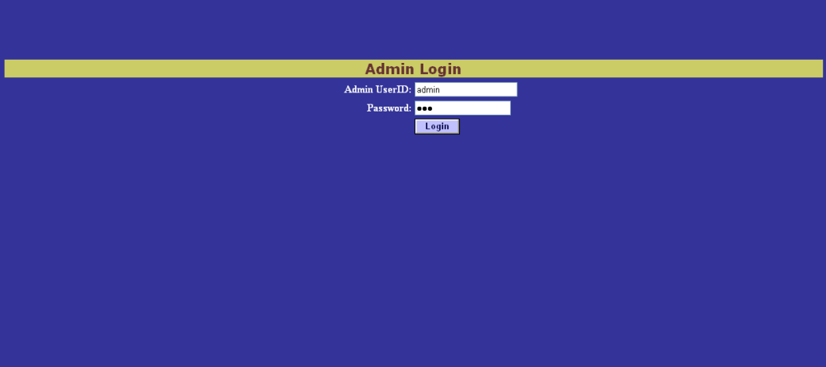

This page is admin login page, in this page only admin access.

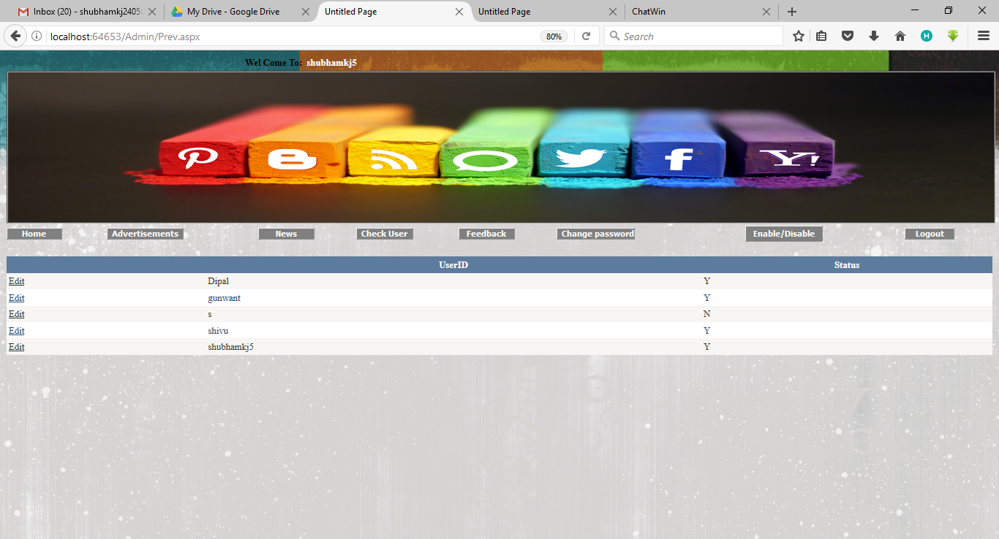**Authentication.aspx**

This page is authentication page in this page only admin edit, no any person. And permit user access his profile.

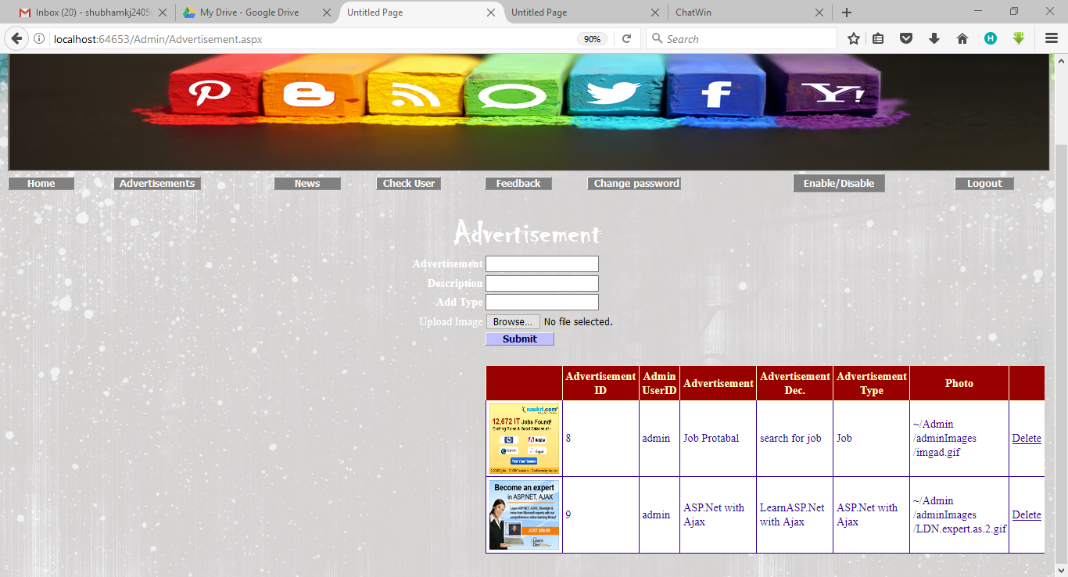 **Advertisements.aspx**

**News.aspx**

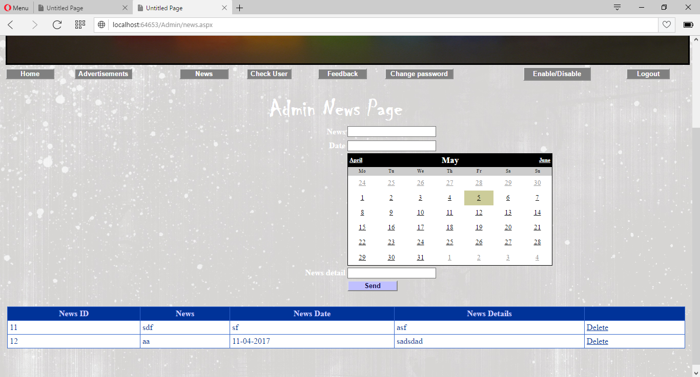

**CheckUser.aspx**

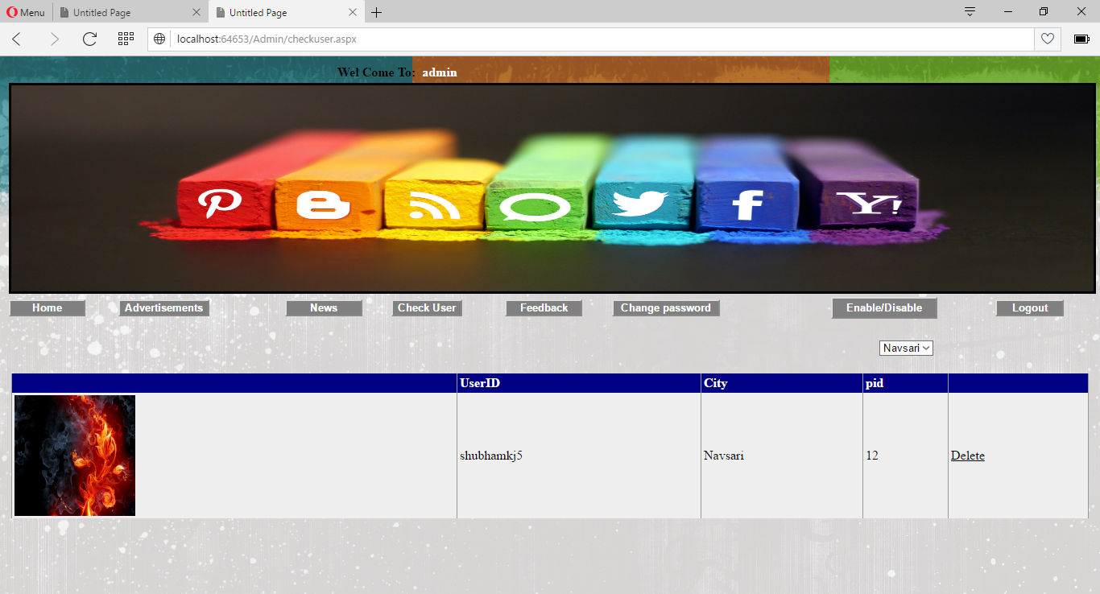

**Feedback.aspx**

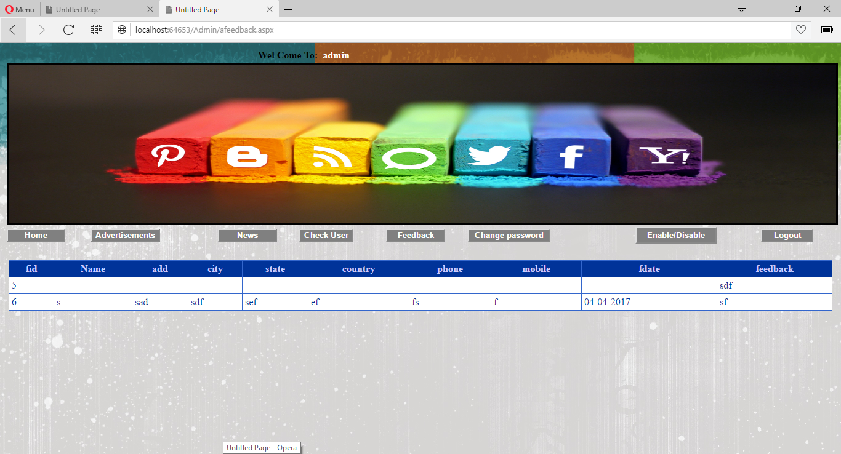

**ChangePass.aspx**

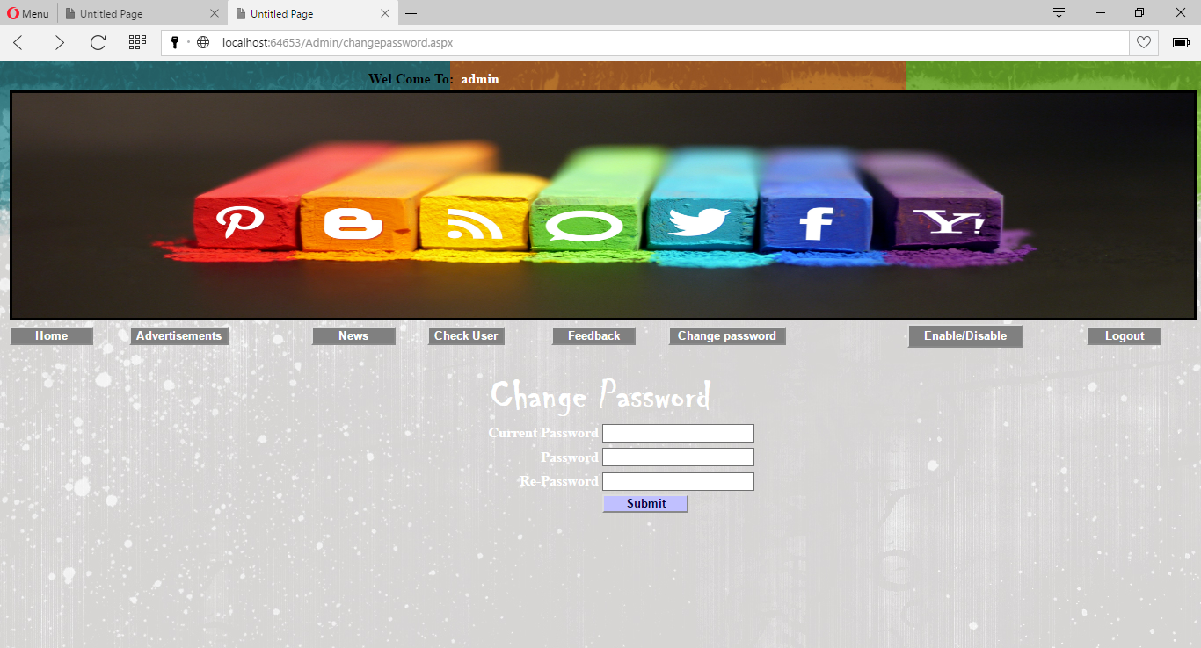

**USER:**

**Login.aspx**

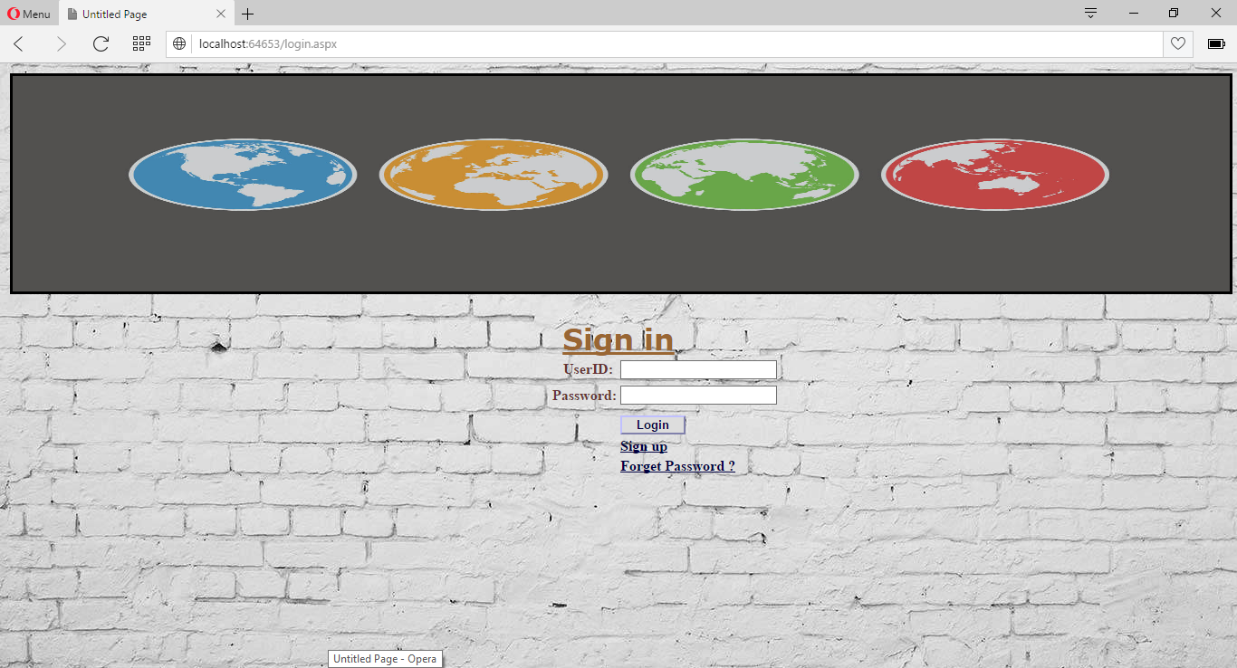

**Register.aspx**

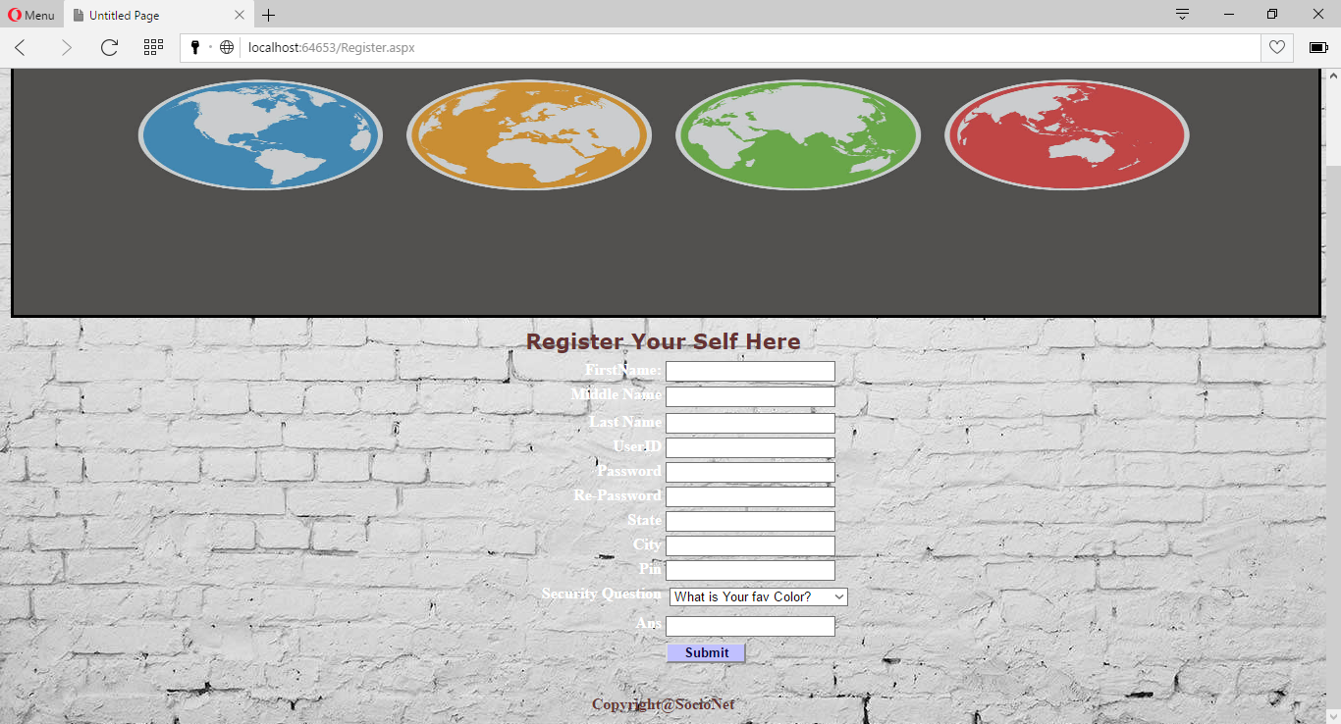

**Home.aspx**

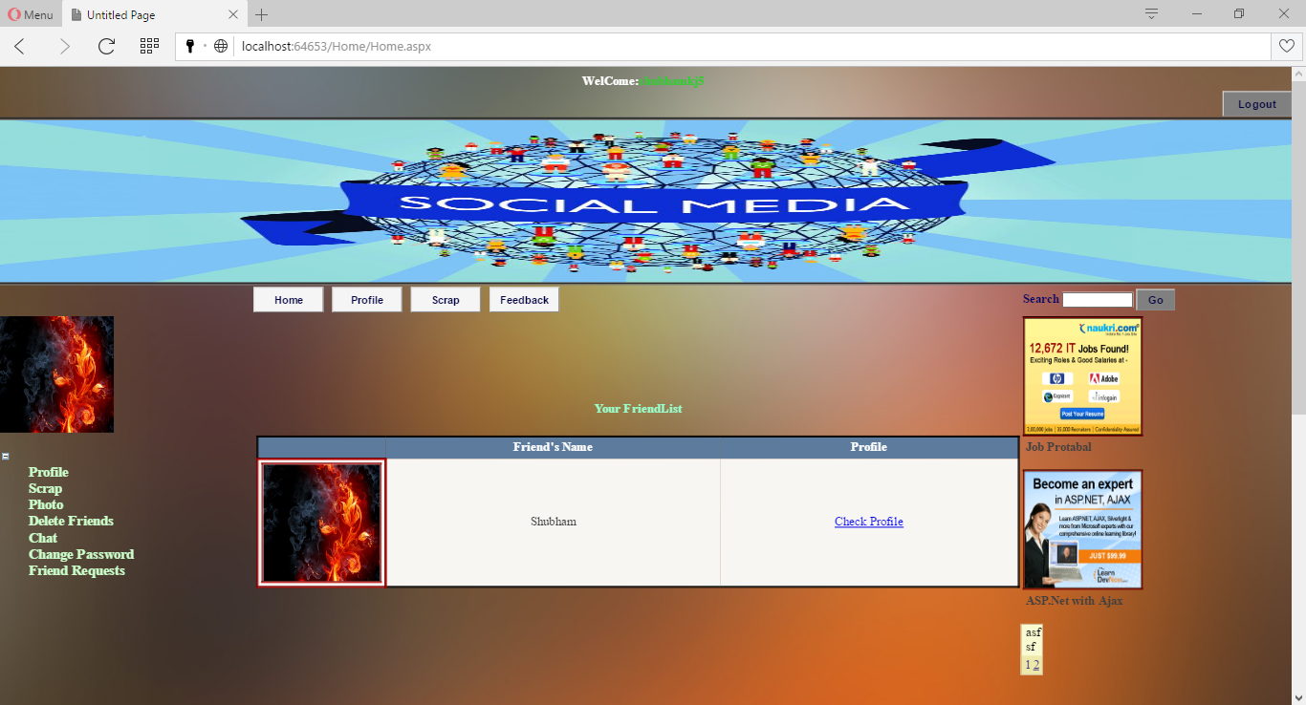

**Profile.aspx**

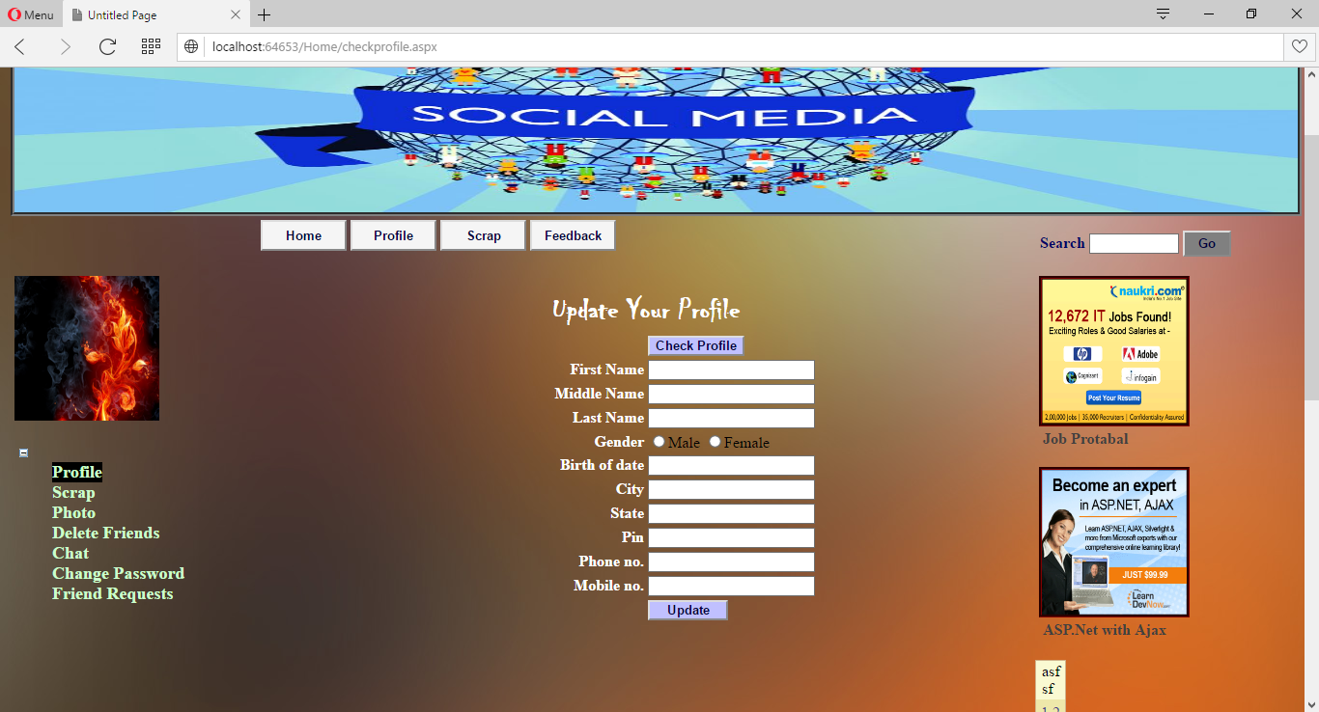

**Feedback.aspx**

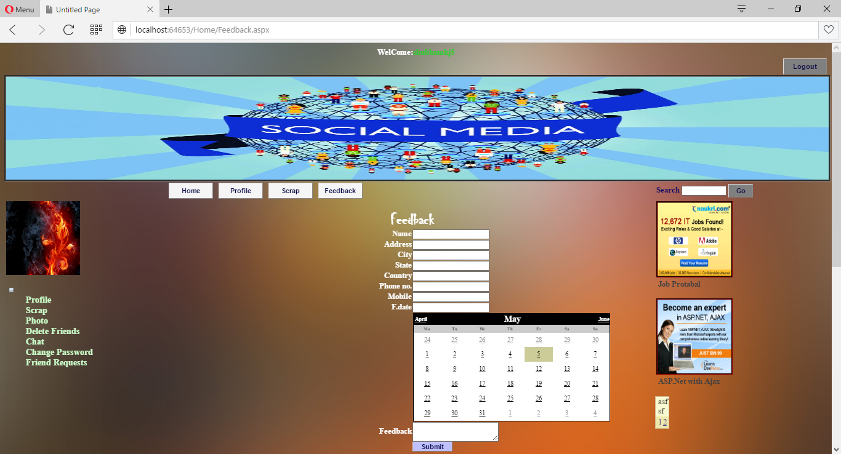

**Search friends.**

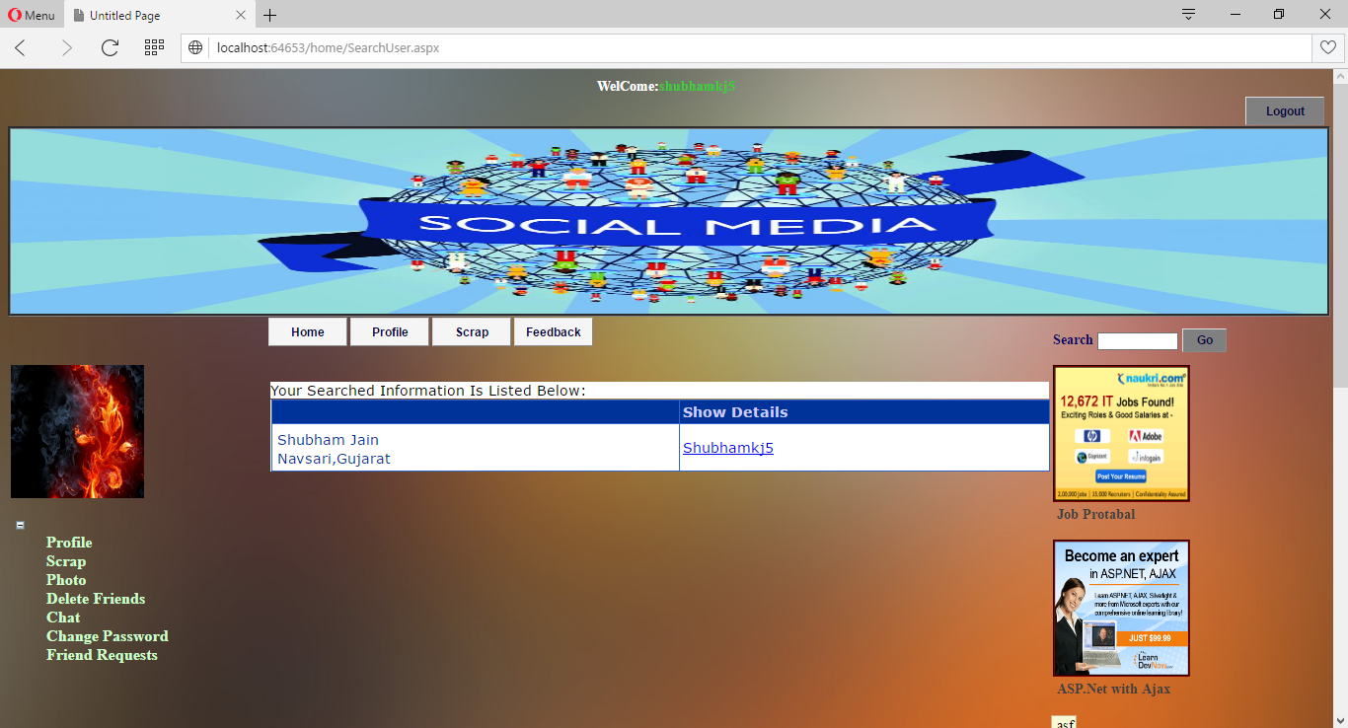

**Requestuser.aspx**

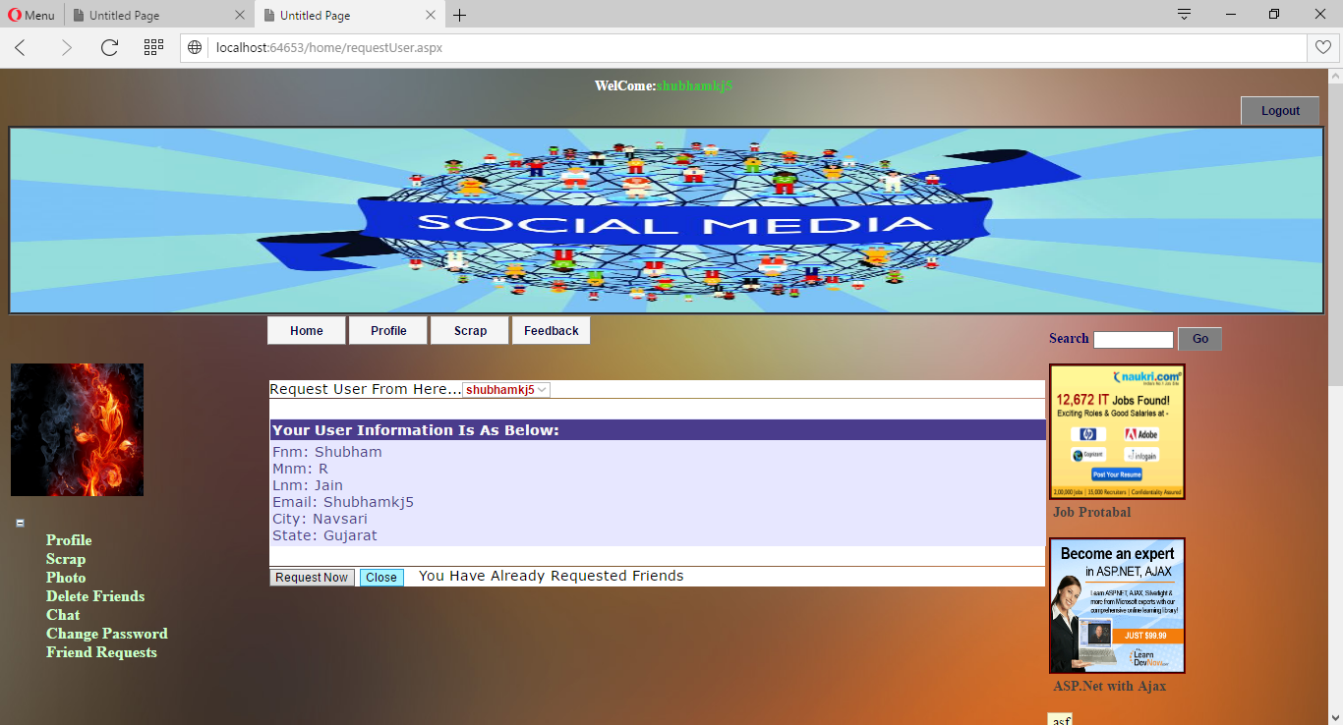

**Scrap.aspx**

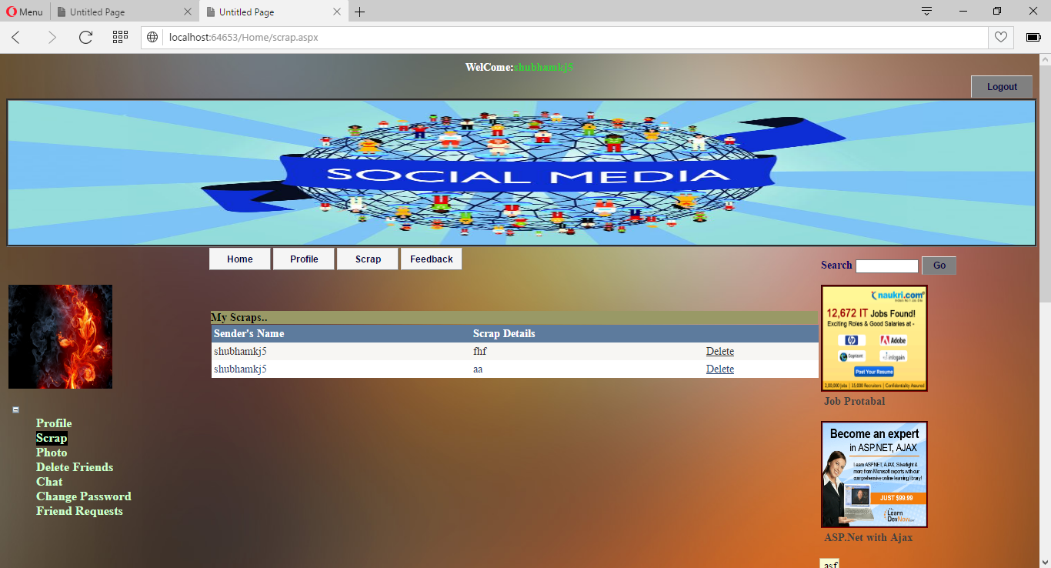

**FriendRequest.aspx**

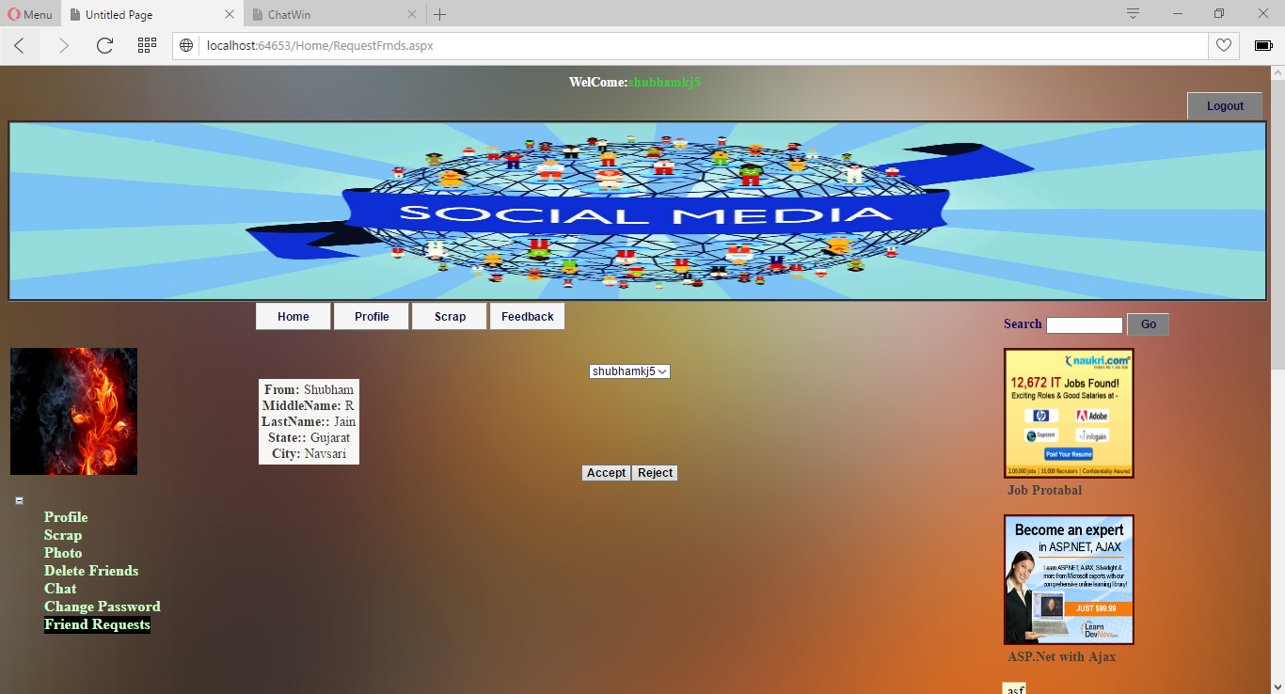

**Chatroom.aspx**

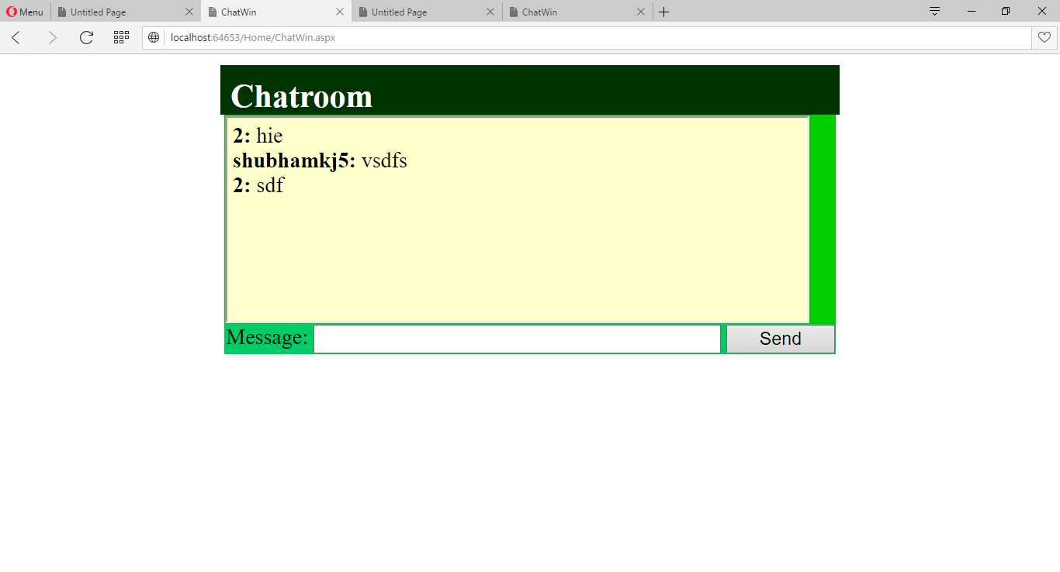

**Testing**

**Importance of software Testing**

The importance of software testing and its impact on software cannot be underestimated. Software testing is a fundamental component of software quality assurance and represents a review of specification, design and coding. The greater visibility of software system and the code associated with software failure are motivating factors for planning, through testing. It is not uncommon for a software organization to spent 40% of its efforts on testing.

**Software Testing Fundamentals**

During testing the software engineering produces a series of test cases that are used to “rip apart” the software they have produced. Testing is the one step in the software process that can be seen by the developer as destructive instead of constructive. Software engineers are typically constructive people and testing requires them to overcome preconceived concepts of correctness and deal with conflicts when errors are identified.

**Black Box Testing**

Black box testing relates to the tests that are performed at the software interface. Although they are designed identify errors, black box tests are used to demonstrate that software function are operational; that inputs are correctly accepted and the output is correctly produced. A black box test considers elements of the system with little interest in the internal logical arrangement of the software. White box testing of the testing involve closer examination of procedural detail. Logical paths through the software are considered by providing test cases that exercise particular sets of conditions and / or loops. The status of the system can be identified at diverse points to establish if the expected status matches the actual status.

Black box testing tries to find errors in the following categories:

1. Incorrect or missing functions,

2. Interface errors,

3. Errors in data structures or external database access,

4. Performance errors, and

5. Initialization and termination errors.

**White Box Testing**

White box testing is a test case design approach that employees the control architecture of the procedural design to produce test cases. Using white box test approaches, the software engineering can produce test cases

1. Guarantee that all independent paths in a module have been exercised at least once.
2. Exercise all logical decisions.
3. Execute all loops at their boundaries and in their operational bounds. Exercise internal data structures to maintain their validity.

**Future Scope**

* In the features we build message, video gallery.
* We also provide high security and reduces disadvantage.
* Reduces high cost.
* Reduce the time consuming.

**Limitation**

* This System is temporary not provide message, video gallery.
* This system is temporary use from company employees.

**Project2 Profile**

|  |  |
| --- | --- |
| **Project Title** | Mood Assessment android application |
| **Project definition** | This android app enables users to note down their mood anytime via different methods and the statistics could help them understand how is their average mood everyday. |
| **Developer** | Shubham Jain |
| **Internal project guide** | Mr. Prashant Hinduja |
| **Minimum Hardware configuration** | Processor : Intel Core-i3 Processor  Ram :4 GB  Hard disk : - 20GB |
| **Front end** | Android Eclipse IDE |
| **Back end** | File Handling |
| **Operating system** | Windows 10 |

**Existing System Study**

* Daily routine life causes depression and also moments that cherish feelings.

* Such feelings could change our behavior in public with close ones and strangers.
* Mood affects our routine life and only after some days we can’t remember how mood has affected our relations.
* A habit of noting down moods eventually can be helpful when we could assess ourselves and improvise.

**Project Definition**

Mood Assessment provides interfaces to identify our moods in a manner you want to represent and note. Every time you note a mood it gets stored and you could check you 30 days summary. It contains below methods for assessment

* **Affect Button :-**  Allows user to identity facial expression and note down mood statistics.
* **SPANE :-** Scale of positive and negative button to rate mood.
* **SPANE(PHOTO) :-** Same as SPANE but with images.

* **PANAS :-** Positive and Negative Affect Schedule measures emotions with slider.

* **PANAS(PHOTO) :-** Same as PANAS with images.
* **PAM :-**  Photographic affect meter to allow users option to select mood with predefined images.

Each method has its own statistics to review user moods on different methods. Other functionalities are :-

**Exporting mood data to pdf**

**Sharing mood data in pdf format**

**Hardware and Software**

Hardware :-( Recommended)

Processor : Intel Core i3 Process

Random Access Memory : (Minimum) 1 GB

Hard Disk : 20 GB

Developing Software :-( Recommended)

Front-End : Eclipse IDE Android

Support : Framework 2.0

Operating System : Windows XP (service pack 2)

Supporting tools : PDF viewer for viewing file

Deploying Environment :- ( Recommended)

Operating System : Android JellyBean 4.1 (Minimum)

RAM : 1 GB

Space : 5 MB

**Additional Libraries**

1. **Achartengine.jar**

Display data in form of charts that creates activity with graphical layouts to display results in the form of structured charts. AChartEngine supports three types of charts:

* **XY Charts** - These charts display data using an X-axis and a Y-axis, for e.g., line, area, bar, scatter.
* **Round Charts** - These are circular charts, for e.g., Pie, Doughnut, Dial.
* **Combined Charts** - These charts display a combination of several XY charts.

1. **itextpdf.jar**

iText is a PDF library that allows you to CREATE, ADAPT, INSPECT and MAINTAIN documents in the Portable Document Format (PDF):

* Generate documents and reports based on data from an XML file or a database
* Create maps and books, exploiting numerous interactive features available in PDF
* Add bookmarks, page numbers, watermarks, and other features to existing PDF documents.
* Split or concatenate pages from existing PDF files
* Fill out interactive forms
* Serve dynamically generated or manipulated PDF documents to a web browser.

**Input & Output Design**

**HOME**

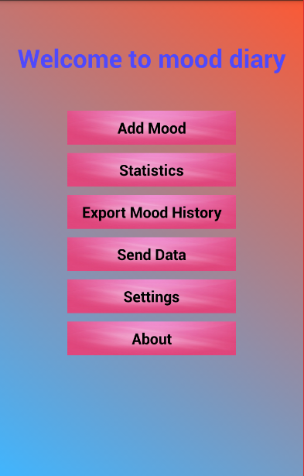

**AFFECT ASSESSMENT**

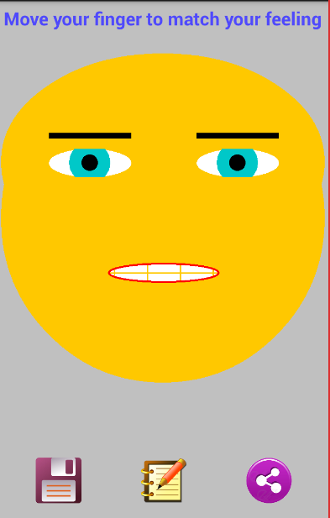

**PANAS(PHOTO)**

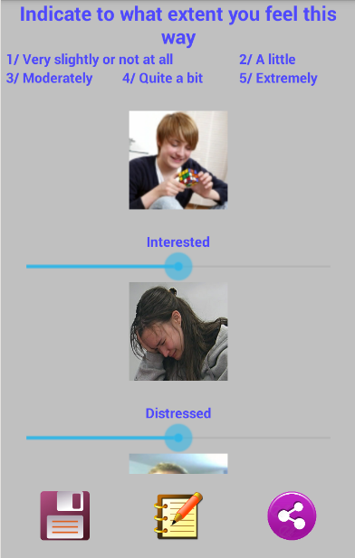

**PANAS**

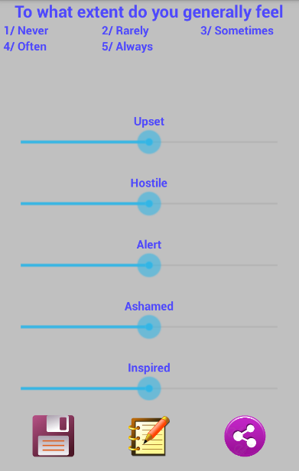

**SPAN**

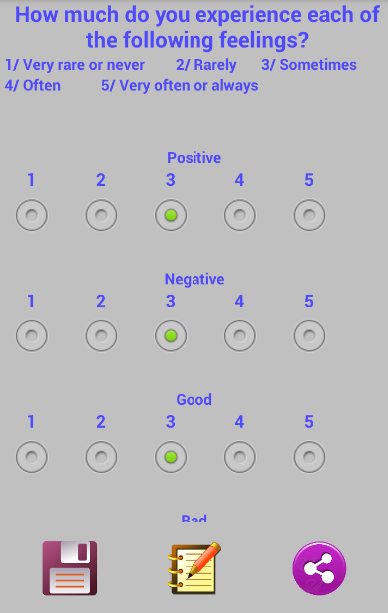

**SPAN(PHOTO)**

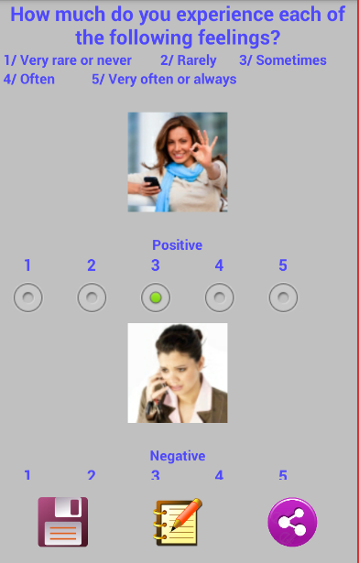

**STATISTICS(TYPE 1)**

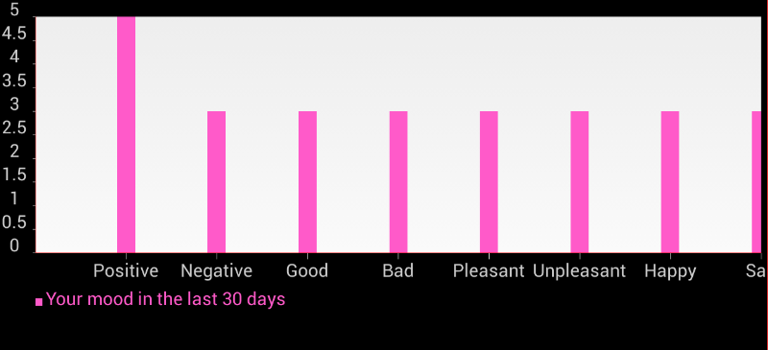

**STATISTICS(TYPE 2)**

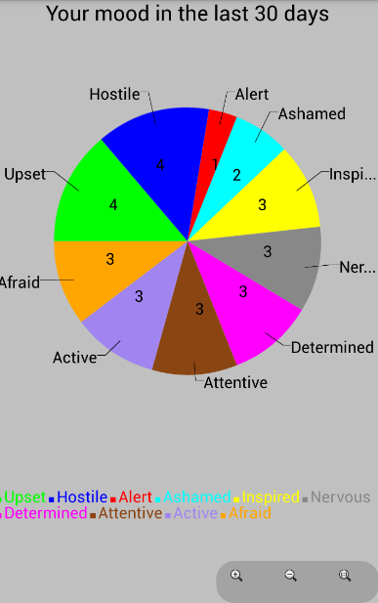

**Future Scope**

* Automatically suggest a mood by analyzing previos mood data.
* Set reminders each day to store mood.
* Provide more simpler methods to record mood using voice recognition.
* Live camera facial detection for recording mood.

**Limitation**

* Does not provide monthly statistics comparison.
* Does not provide any analyzation

**CONCLUSION**

I do not regret anything in this experience and I thank all those who have allowed such a thing feasible. I discovered vast technologies available to complete large deal to code into some steps using api’s.

Also it was fun building such an interactive app for facial expressions and online communities were helpful. This project didn’t stop teaching me until the last phases. Now I could understand the concepts of social networking and help others to find out their moods. I would like to thank my professors and college for providing me this opportunity of proving myself worthy to build something like this,

**Bibliography**

* **Books**

1. System Analysis and Design.

By: James A Sen.

2. Software Engineering.

By: Roger Pressman.

3. Professional ASP.NET 2.0

* **Web site**

[www.google.com](http://www.google.com)

www.wikipedia.com

www.developers.android.com